

**BITA/5/21/040/TZ**

**SHAFAA ABDULRAHMAN JUMA**

**MARKUP TEST REPORT.**

By start with spring boot initializer

We select maven as project and java as language then we choose Small spring boot 2.7.14 value

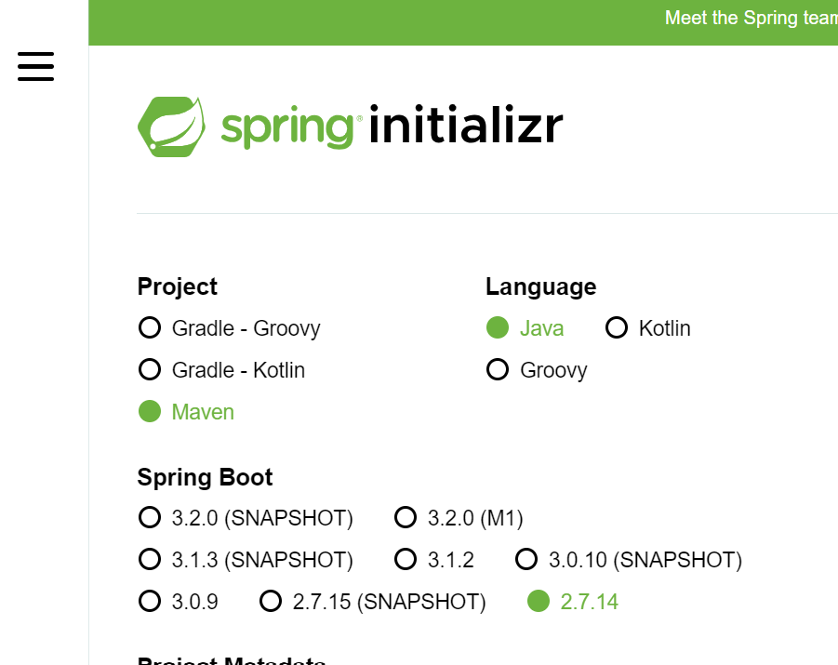

Then we add project Metadata as follow

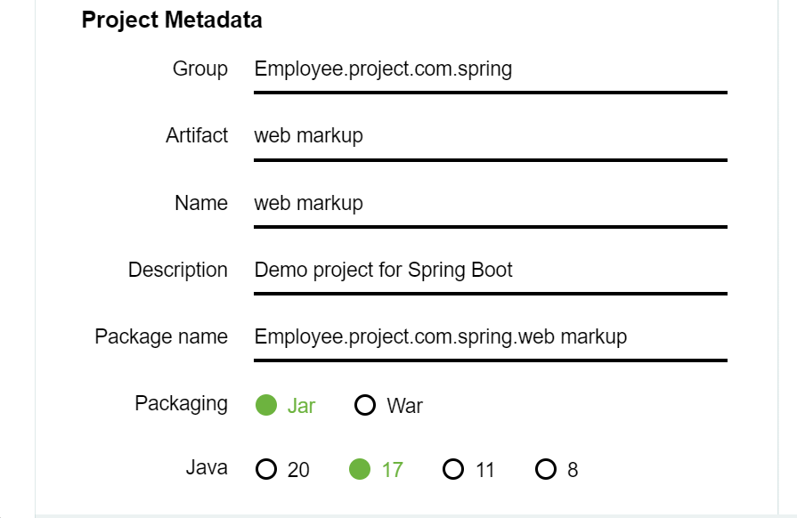

After that we add dependence

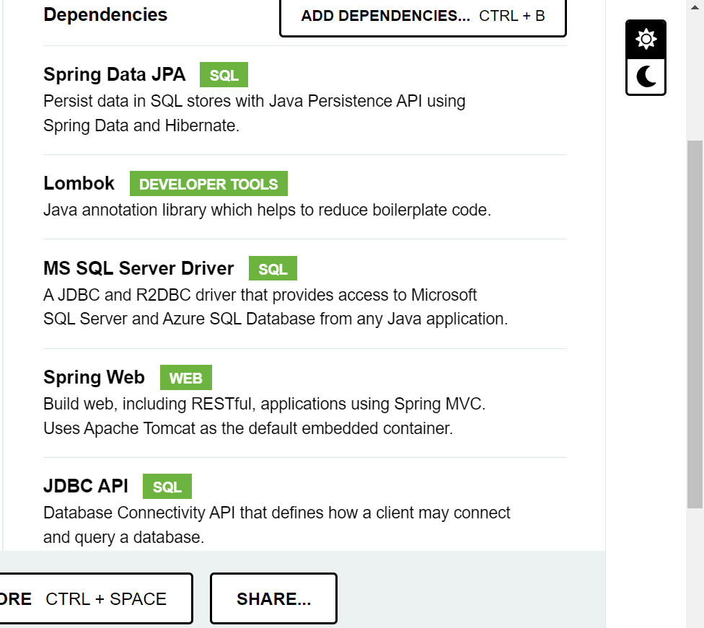

Spring Data JPA its for persist data in SQL

Lombok this is for java annotation library which helps to reduce boilerplate code.

Then after dependencies we generate folder

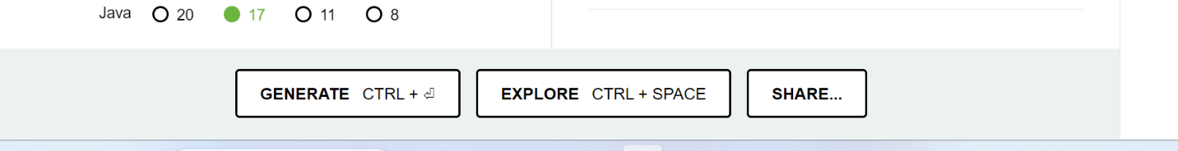

Then the folder is

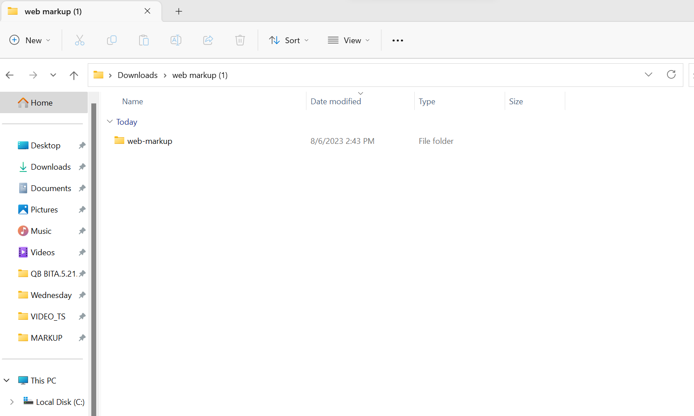

Then.

Applicatipn properties

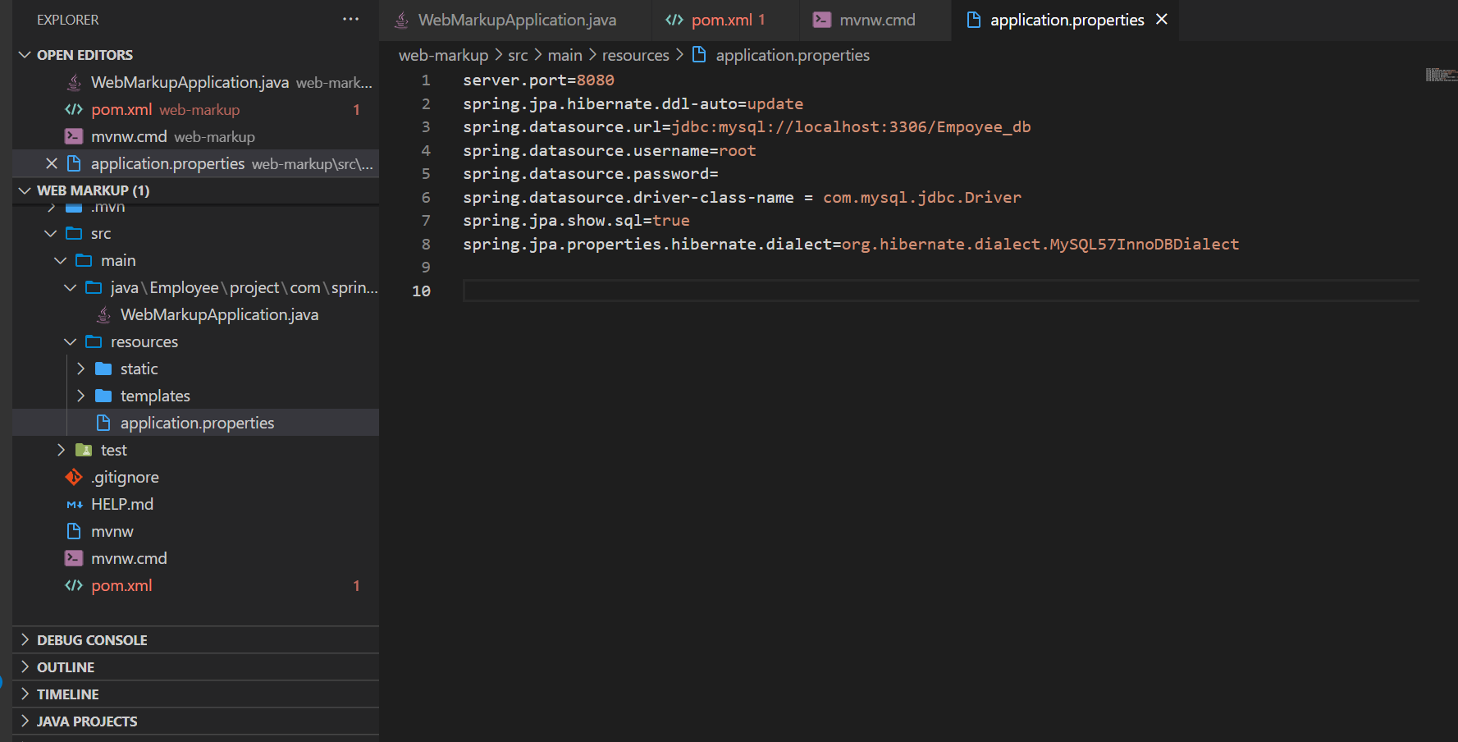

Then we create model folder with its a file called Employee.java

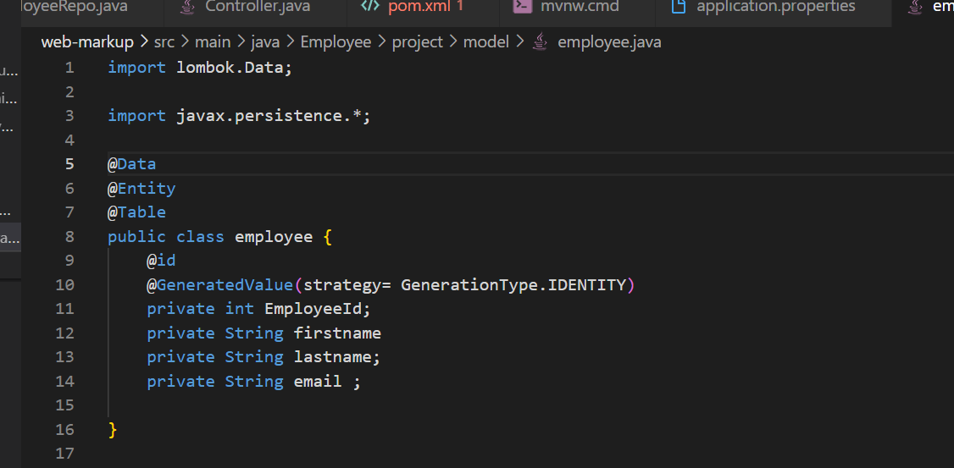

After that we create Repository folder with it’s a file called EmployeeRepo.java

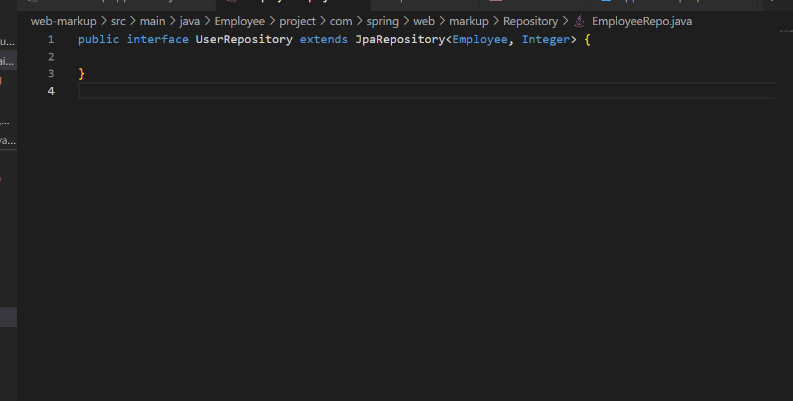

After that we create Controller folder with its file called Controller.java

